Q8.1: A bus-organized CPU similar to Fig. 8-2 has 16 registers with 32 bits in each, an ALU, and a destination decoder.
- How many multiplexers are there In the A bus, and what is the size of each multiplexer?
- How many selection Inputs are needed for MUX A and MUX 8?
- How many inputs and outputs are there in the decoder?
- How many inputs and outputs are there in the ALU for data, including input and output carries?
- Formulate a control word for the system assuming that the ALU has 35 operations.
Solution:

Q8.3: Specify the control word that must be applied to the processor of Fig. 8-2 to implement the following microoperations.
Solution:

Q8.4: Determine the microoperations that will be executed in the processor of Fig. 8-2 when the following 14-bit control words are applied.
- 00101001100101
- 00000000000000
- 01001001001100
Solution:

Q8.8: Convert the following arithmetic expressions from reverse Polish notation to infix notation.
- A B C D E + * - /
- A B C D E */- +
- A B C D E F G + * + * + *
Solution:

Q8.14: A two-word instruction is stored in memory at an address designated by the symbol W. The address field of the instruction (stored at W + 1) is designated by the symbol Y. The operand used during the execution of the instruction is stored at an address symbolized by Z. An index register contains the value X. State how Z is calculated from the other addresses if the addressing mode of the instruction is
- direct
- indirect
- relative
- indexed
Solution:

Q8-18: An instruction is stored at location 300 with its address field at location 301 .The address field has the value 400. A processor register R 1 contains the number 200. Evaluate the effective address if the addressing mode of the instruction is (a) direct; (b) immediate; (c) relative; (d) register indirect; (e) index with R1 as the index register.
Solution:

Q8-25: An 8-bit computer has a register R. Determine the values of status bits C, 5, Z, and V (Fig. 8-8) after each of the following instructions. The initial value of register R in each case is hexadecimal 72. The numbers below are also in hexadecimal.
- Add immediate operand C6 to R .
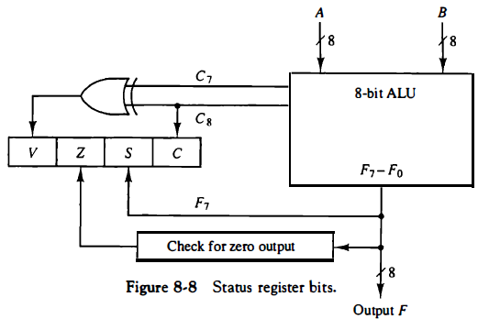
- Add immediate operand 1 E t o R .
- Subtract immediate operand 9 A from R .
- AND immediate operand 8 0 t o R .
- Exclusive-OR R with R .

Solution:

Q8-26: Two unsigned numbers A and B are compared by subtracting A - B. The carry status bit is considered as a borrow bit after a compare instruction in most commercial computers, so that C = 1 if A < B. Show that the relative magnitude of A and B can be determined from inspection of status bits C and Z as specified in the table for Problem 8-26. (See also Table 8-11)
Solution:

Q8-32: The content of the top of a memory stack is 5320. The content of the stack pointer SP is 3560. A two-word call subroutine instruction is located in memory at address 1120 followed by the address field of 6720 at location 1121 . What are the content of PC, SP, and the top of the stack:
- Before the call instruction is fetched from memory?
- After the call instruction is executed?
- After the return from subroutine?
Solution:

